Touchplates: Low-Cost Tactile Overlays for Visually Impaired Touch Screen Users

【Main Content】：

We introduce touchplates, carefully designed tactile guides that provide tactile feedback for touch screens in the form of physical guides that are overlaid on the screen and recognized by the underlying application. Unlike prior approaches to integrating tactile feedback with touch screens, touchplates are implemented with simple plastics and use standard touch screen software, making them versatile and inexpensive. Touchplates may be customized to suit individual users and applications, and may be produced on a laser cutter, 3D printer, or made by hand.

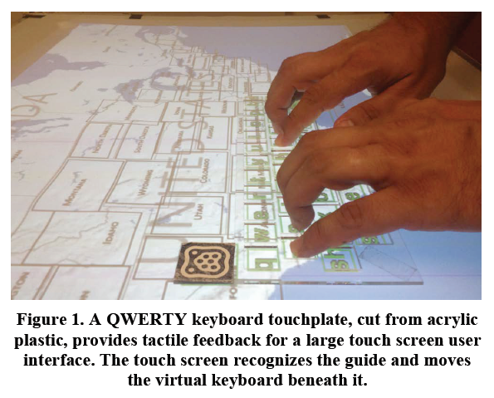 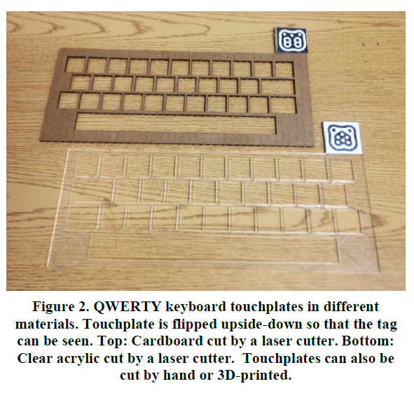

【Divide existing methods of making the touch screen accessible to the blind】：

Software-Only

Hardware-Only

Hybrid

【Hardware】：

Although prior research in HCI has not explored the use of passive overlays to improve touch screen accessibility for blind people, similar overlays have recently become available commercially. These overlays may take the form of cases or screen protectors for touch screen devices, and typically provide a series of bumps over a predefined region on the screen. For example, the TouchFire3 keyboard overlay for Apple’s iPad featured a series of squishy silicon key-bumps over the screen, making it easier for users to touch type. These devices can provide some tactile feedback, which may improve usability. However, they are typically fixed to the screen, and cannot be easily moved or altered. Furthermore, such overlays do not typically communicate with the underlying device software, meaning the software is unaware whether the overlays are being used or not.

【Interacting with Touchplates】：

•Touch inside. Touchplates may have holes cut into them. Placing a fingertip inside one of these holes creates a direct touch connection with the touch screen. The offset of the touch from the detected visual tag allows the system to determine which region of the touchplate was touched.

•Touch upon. Some touchplates are made from materials that are transparent to infrared light. This makes it possible to detect when the user is touching the body of the touchplate. This creates a second touch surface that can be used, for example, to preview actions on the touch screen.

•Touch outside. Touchplates can also serve as frames of reference for nearby touches that occur just outside the touchplate, such as along an edge or at a corner point of the touchplate.

•Move. The touchplate itself can be pushed across the surface of the touch screen, providing additional input.

•Rotate. The body of the touchplate can be rotated like a knob, or placed in a specific orientation, to provide input.

•Place and remove. The user may place a touchplate on the screen, or remove an existing touchplate, to change application modes or provide input.

•Flip. By placing a visual tag on each side of a touchplate, the system can identify which side of the touchplate has been placed down. Users can then flip the touchplate to see alternate information or enable different interaction modes.

【Developed a set of presentation Touchplates to support exploring various interactions】：

(a) QWERTY keyboard. A laptop-sized keyboard. Keys may be cut out of the touchplate body, or may be marked with tactile features in the case of a transparent touchplate.

(b) Numeric keypad. Similar to the QWERTY keyboard, but designed to mimic a traditional numeric keypad.

(c) Menu bar. A notched, ruler-shaped overlay. May be used to retrieve a system menu by touching over or along the touchplate, with each notch corresponding to a menu item.

(d) Ring. A hollow, ring-shaped overlay. May be used to adjust parameters by touching on or around the ring, and to confirm a parameter by touching inside. May also be rotated like a knob.

(e) Window. A hollow, window-shaped overlay. Primarily used to provide an alternative view of the touch screen. May be flipped over to present an additional view.

(f) Mouse. May be slid across the surface like a mouse. Provides two button-shaped cut-outs for alternate selection.

(g) Map. An example of a domain-specific tactile graphic cutout. Such cutouts might be fabricated and used as needed.

(h) Tokens. These overlays provide no interactive cut-outs, but each has a unique shape. May be used by placing the token on screen, rotating the token, or touching around the token.

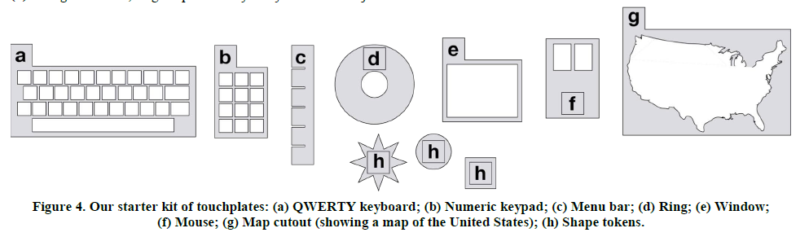

【Evaluate】： (Detail in Paper)

**QWERTY keyboard**

**Numeric keypad**

**Menu bar**

**Ring**

**Window**

**Mouse**

**Map**

**Tokens**

【Questionnaire】：

**Preference of touchplates vs. on-screen gestures.**

**Favorite and least favorite touchplates.**

**Suggested touchplates.**

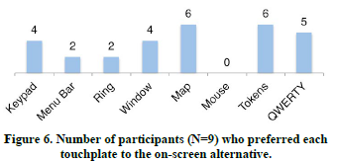 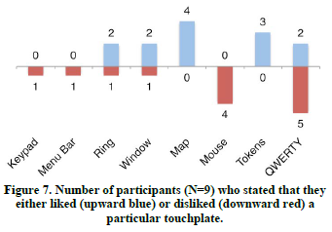

【Usability Challenges】：

Material friction.

Bimanual interaction.

Visual contrast.

**【Conclusion】：**

Although not all participants are keen to adopt a touchpad, even some participants who do not want to use the touchpad themselves point out that they may be useful to others.